Stock Projections to Rebuild WCNPO striped marlin
under WCPFC CMM 24-06

Jon Brodziak*
* Pacific Islands Fisheries Science Center
National Marine Fisheries Service
1845 Wasp Boulevard
Honolulu, HI 96818 USA
Email: Jon.Brodziak@NOAA.GOV

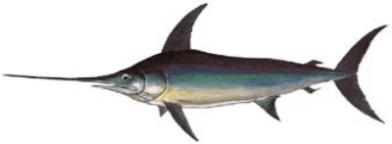
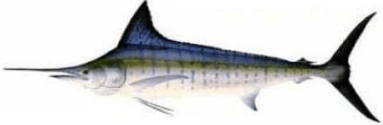

Introduction
The Western and Central Pacific Fisheries Commission adopted Conservation and Management Measure (CMM) 2024-06 for Western and Central North Pacific Ocean (WCNPO) striped marlin at the 21st Commission meeting. CMM 2024-06 superceded CMM 2010-01 with a total catch limit of 2400 mt for WCPFC countries during 2025-2027 along with provisions for carryover catches if observed catches were under the catch limit. Under CMM 2024-06 (https://cmm.wcpfc.int/measure/cmm-2024-06), Commission Members, Cooperating Non-Members, and Participating Territories (CCMs) agreed to ensure that the total catch WCNPO striped marlin will not exceed 2400 mt of catch for each year between 2025 – 2027. This catch limit is based on a 60% reduction from the highest catch between 2000 and 2003. If CCMs cumulatively catch in excess of 2400 mt in any given year, the CMM 24-06 will be reviewed the following year. The CMM 24-06 is planned to be reviewed and amended as needed in 2027, pending the completion of a new stock assessment conducted by the ISC.
This working paper analyzes three alternative rebuilding scenarios under CMM 2024-06 which provides for carryover allowances if WCNPO striped marlin (MLS) catch limits are not exceeded in a year. In particular, if the annual catch limit of 2,400 metric tons of MLS is not fully utilized in a given year, then CCMs may carryover up to 165 metric tons of their individual quota to the following year. CMM 24-06 states that “In 2023, there was an 826 mt underage of the TAC of 2400 mt that will be available to CCMs fishing in 2025. Any underage from 2024 will be available to CCMs in 2026, and any underage from 2025 will be available to CCMs in 2027.” Potential catch underages in 2024 and 2025 would lead to carryover catches in 2026 and 2027, respectively. However, no CCM may exceed a 165 metric ton increase in any carryover year, and any overage of an individual limit would be deducted from that country's catch limit in the subsequent year. This working paper describes rebuilding projections to analyze three scenarios for potential catch underages and subsequent carryover of MLS catches during 2025-2027. Overall, the goal is to show how projected MLS rebuilding outcomes would change under different carryover catch scenarios.
The ISC Billfish Working Group (BILLWG) reviewed CMM 2024-06 at its January 2025 meeting and agreed to analyze three additional projections to measure the impacts of including carryover catches for 2025-2027 in MLS rebuilding analyses. The first scenario represented a constant annual catch of 2400 mt with no carryover during 2025-2027 (Table 1). Scenario 1 catches in 2028-2031 and 2032-2034 were set at 2300 mt and 2200 mt, respectively, to illustrate reaching at least a 60% probability of achieving the MLS rebuilding target in 2034. The second scenario set catch at 3225 mt in 2025 and 2400 mt during 2026-2027. Scenario 2 represented a catch measure with carryover in 2025 from 2023 (Table 1). Scenario 2 catches in 2028-2031 and 2032-2034 were set at 2200 mt to illustrate reaching at least a 60% probability of meeting the MLS rebuilding target in 2034. The third scenario set catch at 3225 mt in 2025-2026 and 2400 mt during 2027. Scenario 3 represented a catch measure with carryover in 2025-2026 (Table 1). Scenario 3 catches in 2028-2031 and 2032-2034 were set at 2150 mt to illustrate reaching at least a 60% probability of achieving the MLS rebuilding target in 2034. Overall, these scenarios showed how potential carryover catches during 2025-2026 would affect stock rebuilding under CMM 2024-06.
Methods
The 2024 rebuilding analyses for WCNPO striped marlin were modified to run the three projections. The CMM 2024-06 projections used the exact same projection model configuration as used in the 2024 MLS rebuilding analyses (Brodziak 2024), which in turn were developed based on the 2023 benchmark stock assessment (ISC BILLWG 2023).
Projection Model
Rebuilding projections for WCNPO striped marlin were conducted using an age-structured projection model (Brodziak et al. 1998). This stochastic projection model can account for uncertainty in initial population size, future variability in recruitment, and process errors in life history and fishery selectivity parameters (AGEPRO software available at: https://nmfs-fish-tools.github.io/AGEPRO/). Uncertainty in the initial striped marlin population size in 2021 was characterized by calculating 100 bootstrap replicates of population size at age using the bootstrapping option in the assessment model Stock Synthesis ([SS3], Methot and Wetzel 2013, https://nmfs-ost.github.io/ss3-website/). This produced a sampling intensity of about 60 bootstraps per 1,000 mt of spawning biomass and generated a distribution of initial population sizes at age in 2021 for the projections. Future variability in recruitment was modeled as a 3-model mixture of short-, medium-, and long-term recruitment dynamics. In each projection, 1000 simulations were run for each bootstrap replicate to characterize the effects of process errors in future recruitment, life history, and fishery parameters. The stochastic projections used the 2023 assessment estimates of the multi-fleet, fishery selectivities at age by fleet group (Table 2) to produce consistent results. In each projection, life history parameters at age were randomly sampled using a multiplicative lognormal error with a mean of unity and a CV of 10% to represent future process error, with the exception of maturity at age, which was sampled with a CV of 1%. Similarly, fishery selectivity at age parameters was sampled with a multiplicative lognormal process error with a mean of unity and a CV of 10% to represent process error future selectivities.
Catch Data
We used the most recent catch data to update the initial harvest information from the 2024 rebuilding analyses. In particular, the input catch data used for the three scenarios differed from those used in the 2024 rebuilding analyses in two ways. First, we collected new catch data during 2021-2024 to calculate spawning biomasses and fishing mortalities during 2021-2024 from the last year of the stock assessment in 2020. In this case, the best catch data during 2021-2024 replaced the status quo fishing mortality that was used to project harvests of WCNPO striped marlin in 2021-2024 in the 2024 rebuilding analyses (Brodziak 2024). Second, the average proportion of catch by country and assessment fleet group in 2020 was used to apportion catch by country to fleet groups during 2025-2027 (Tables 2 and 3, Figures 1.1-1.9). This apportionment was needed because two countries, Japan and Taiwan, both had fishing fleets in two or more assessment fleet groups harvesting striped marlin. As a result, the three scenarios used 2021-2024 catch data to initialize the projection runs, applied the scenario-specific catch allocations in 2025-2027, and then set catches during 2028-2034 to rebuild MLS with at least a 60% probability in 2034.
We set the input WCNPO striped marlin catch data in 2021-2024 based on the 2024 WCPFC Tuna Fishery Yearbook (WCPFC 2024, https://www.wcpfc.int/doc/wcpfc-tuna-fishery-yearbook-2024) for all CCMs reporting MLS catches, except Japan and the U.S. The WCPFC Yearbook data was considered to provide the best information on recent catches of WCNPO striped marlin in the WCPFC Area north of the equator by China, Kiribati, Korea, Marshall Islands, Nauru, Vanuatu, and Taiwan during 2021-2023 (Figures 2.1 and 2.2). We note that the 2024 MLS catches were not yet reported in the 2024 WCPFC Yearbook and MLS catches in 2024 were assumed to equal the reported 2023 catch values for each country.
Japanese catch data during 2021-2024 were based on reported catches gathered from each of the 15 Japanese fleets (Table 2) and 7 fleet groups (Table 3, Figures 1.1 to 1.7 and 3) defined in the most recent MLS stock assessment (ISC BILLWG 2023). Reported catches by fleet were based on catch data collected from the most recent 2025 database sources (Table 4, M. Jusup, personal communication, February 26, 2025).
The U.S. catch data for 2021-2024 were based on reported catches for the Hawaii commercial longline fleet and for the Hawaii recreational fleet (Table 2, Figure 1.8). Reported catches by fleet were based on catch data collected from the most recent 2025 database sources (Table 5 and Figure 4).
Annual MLS catch data by fishing fleet for 2021-2024 were allocated to the 9 fleet groups used in the 2023 WCNPO striped marlin stock assessment (Table 2, Figures 1.1-1.9). Catches by fleet for each country were uniquely assigned to a single fleet group for all countries, except Japan and Taiwan. Japanese catches by fleet in 2021-2024 were assigned to fleet group based on the observed proportion of Japanese catch by fleet group in 2020 (Table 6 and Figure 5.1). Taiwanese catches by fleet in 2021-2024 were assigned to fleet groups G7 and G9 (Figures 1.7 and 1.9) based on the observed proportions of Taiwanese catch biomass by fleet group in 2020 (Figure 5.2), which were 9% and 91%, respectively. This led to the best available information on observed MLS catch biomasses in 2021-2024 (Table 7). For comparison, these observed catches were contrasted with the predicted catches from the 2024 rebuilding analyses which were based on an assumed constant fishing mortality during 2021-2024. Overall, each CMM 2024-06 catch scenario used the same observed catches and fleet group allocations to initialize the projections in 2021-2024.
Projected MLS catches by country during the 2025-2027 CMM 2024-06 phase were allocated to the 9 fleet groups based on the maximum CMM 2024-06 carryover catch values under each scenario. For the first scenario with no carryover catch, annual MLS catches were set at 2400 mt during 2025-2027. Under the second scenario with carryover catch in 2025, annual catches were set at 3225 mt in 2025 and at 2400 mt in 2026-2027. For the third scenario with carryover catches in 2025-2026, annual catches were set at 3225 mt in 2025-2026 and at 2400 mt mt in 2027.
Catches during the second (2028-2031) and third (2032-2034) phases of the projection time horizon were set to ensure that a rebuilding probability of at least 60% was achieved in 2034. Noting that the CMM 2024-06 is planned to be amended if needed in 2027, annual catches in rebuilding phases 2 and 3 under scenarios 2 and 3 were reduced from the status quo catch of 2400 mt by an amount sufficient to achieve the rebuilding target.
Results
For each CMM 2024-06 scenario, the projections used the same input data and model configurations used by the ISC Billfish Working Group for the 2024 rebuilding analyses, with the exception of the initial harvests during 2021-2024. For the 2024 rebuilding projections, the recent average fishing mortality during 2018-2020 was used to determine set the initial catches during 2021-2024. Under this assumption of status quo fishing mortality, the projected median catches during 2021-2024 were 2910, 3380, 3320, and 3030 mt, respectively (Brodziak 2024, Table 10.9, scenarios 1-6). In comparison, for the CMM 2024-06 projections, observed annual catches during 2021-2023 and imputed catches for 2024 were based on the 2024 WCPFC Yearbook data, except for Japan and the U.S., as described above. The annual catches in 2021-2024 used for the CMM 2024-06 projections were 1540, 1470, 1685, and 2157 mt, respectively. In comparison, the observed catches in 2021-2024 for the CMM 2024-06 projections were 48%, 57%, 50%, and 30% below the predicted catches in 2021-2024 from the 2024 rebuilding projections (Figure 6.1) which were based on recent average fishing mortality (Figure 6.2). As a result, the CMM 2024-06 projections were initialized in 2021-2024 (Figure 6.2) with much lower fishing intensities than the 2024 rebuilding projections.
Projected spawning biomass
Projected fishing mortality

Discussion
References
Brodziak J, Rago P, Conser R. 1998. A general approach for making short-term stochastic projections from an age-structured fisheries assessment model. In F. Funk, T. Quinn II, J. Heifetz, J. Ianelli, J. Powers, J. Schweigert, P. Sullivan, and C.-I. Zhang (Eds), Proceedings of the International Symposium on Fishery Stock Assessment Models for the 21st Century. Alaska Sea Grant College Program, Univ. of Alaska, Fairbanks. Available at: https://www.researchgate.net/publication/267682539_A_General_Approach_for_Making_Short-Term_Stochastic_Projections_from_an_Age-Structured_Fisheries_Assessment_Model
Brodziak J. 2024. Rebuilding Scenarios for striped marlin in the Western and Central North Pacific Ocean. International Scientific Committee for Tuna and Tuna-Like Species in the North Pacific/Billfish WG, ISC/24/BILLWG-01/03, 151 p. Available at: https://isc.fra.go.jp/pdf/BILL/ISC24_BILL_1/ISC_24_BILLWG-01_03.pdf
ISC Billfish WG. 2023. Annex 14: Stock Assessment Report for striped marlin (Kajikia audax) in the Western and Central North Pacific Ocean through 2020, 12-17 July 2023. Kanazawa, Japan. ISC/23/Annex14, 113 p. Available at: https://isc.fra.go.jp/pdf/ISC23/ISC23_ANNEX14-Stock_Assessment_Report_for_WCNPO_Striped_Marlin-FINAL.pdf
Methot RD, Wetzel CR. 2013. Stock Synthesis: a biological and statistical framework for fish stock assessment and fishery management. Fish. Res., 142, 86–99. https://doi.org/10.1016/j.fishres.2012.10.012.
Table 1. Three rebuilding scenarios for WCNPO striped marlin with alternative carryover catch amounts during 2025-2027 under CMM 24-06.

Table 2. Fishing fleets and fleet groups with equal fishery selectivity used in the base case model of the 2023 stock assessment and in the 2025 rebuilding scenarios under CMM 24-06, where the representative fishery selectivity fleet for each fleet group is shown in bold.

Table 3. WCNPO striped marlin catch biomass (mt) by assessment fleet group and fleet in 2020.

Table 4. Japanese catch biomass (mt) of WCNPO striped marlin by fleet group, 2021-2024.

Table 5. U.S. catch biomass (mt) of WCNPO striped marlin, 2021-2024.

Table 6. Total and proportion of WCNPO striped marlin catch biomass in 2020 by assessment fleet group along with Japanese total and proportion of WCNPO striped marlin catch biomass by fleet group.

Table 7. Best scientific information available for WCNPO striped marlin catch biomass (mt) used for 2025 CMM 24-06 projections.

Table 8.1. Projections of annual spawning biomass distributions (thousand mt) during 2021-2034 under Scenario 1 with no carryover catch where the column heading “Pz” denotes the z^{th} percentile of the annual distributions.

Table 8.2. Projections of annual spawning biomass distributions (thousand mt) during 2021-2034 under Scenario 2 with carryover catch in 2025 where the column heading “Pz” denotes the z^{th} percentile of the annual distributions.

Table 8.3. Projections of annual spawning biomass distributions (thousand mt) during 2021-2034 under Scenario 3 with carryover catch in 2025-2026 where the column heading “Pz” denotes the z^{th} percentile of the annual distributions.

Table 9.1. Projections of annual fishing mortality distributions during 2021-2034 under Scenario 1 with no carryover catch where the column heading “Pz” denotes the z^{th} percentile of the annual distributions.

Table 8.2. Projections of annual fishing mortality distributions during 2021-2034 under Scenario 2 with carryover catch in 2025 where the column heading “Pz” denotes the z^{th} percentile of the annual distributions.

Table 8.3. Projections of annual fishing mortality distributions during 2021-2034 under Scenario 3 with carryover catch in 2025-2026 where the column heading “Pz” denotes the z^{th} percentile of the annual distributions.

Table 10.1. Projections of probabilities of achieving the rebuilding target during 2021-2034 under three scenarios for carryover catch.

Table 10.2. Projections of probabilities of overfishing during 2021-2034 under three scenarios for carryover catch.

Figure 1.1. Fleet group 1

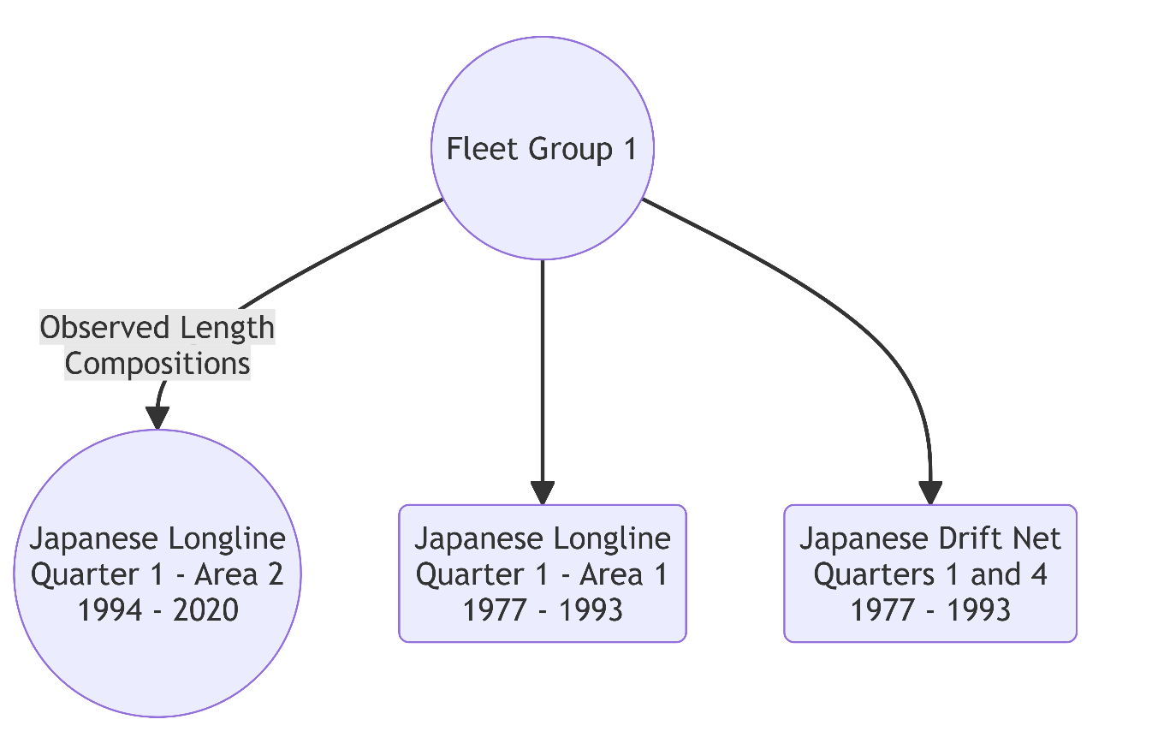

Figure 1.2. Fleet group 2

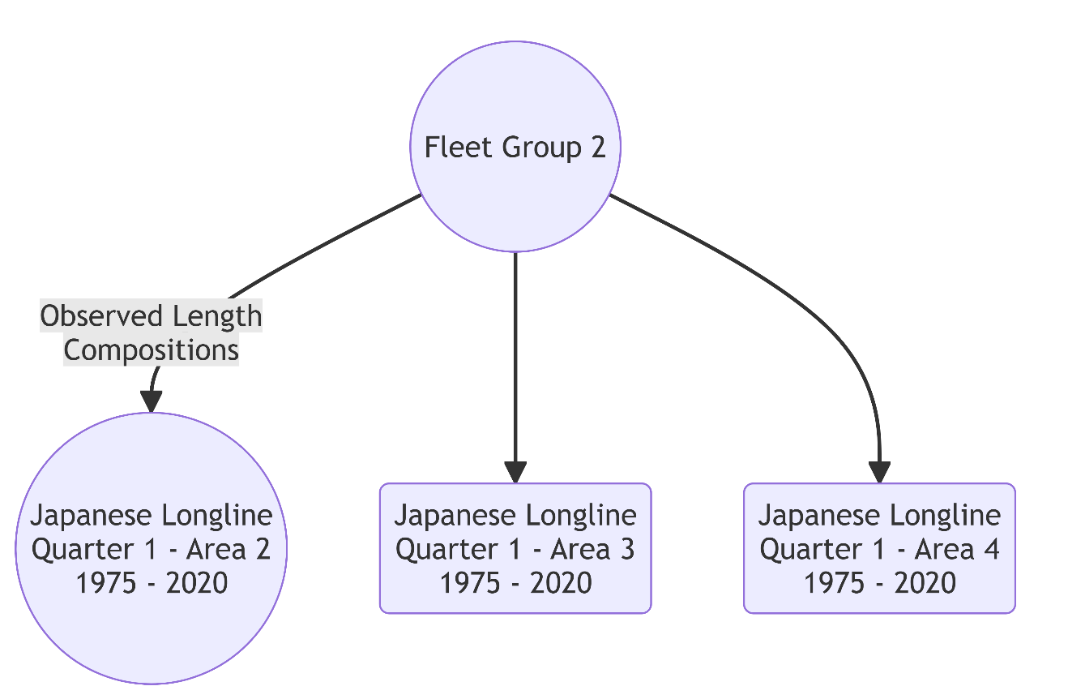

Figure 1.3. Fleet group 3

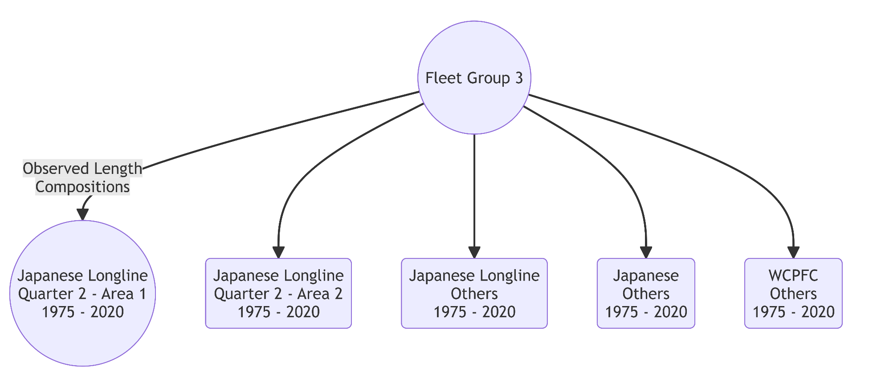

Figure 1.4. Fleet group 4

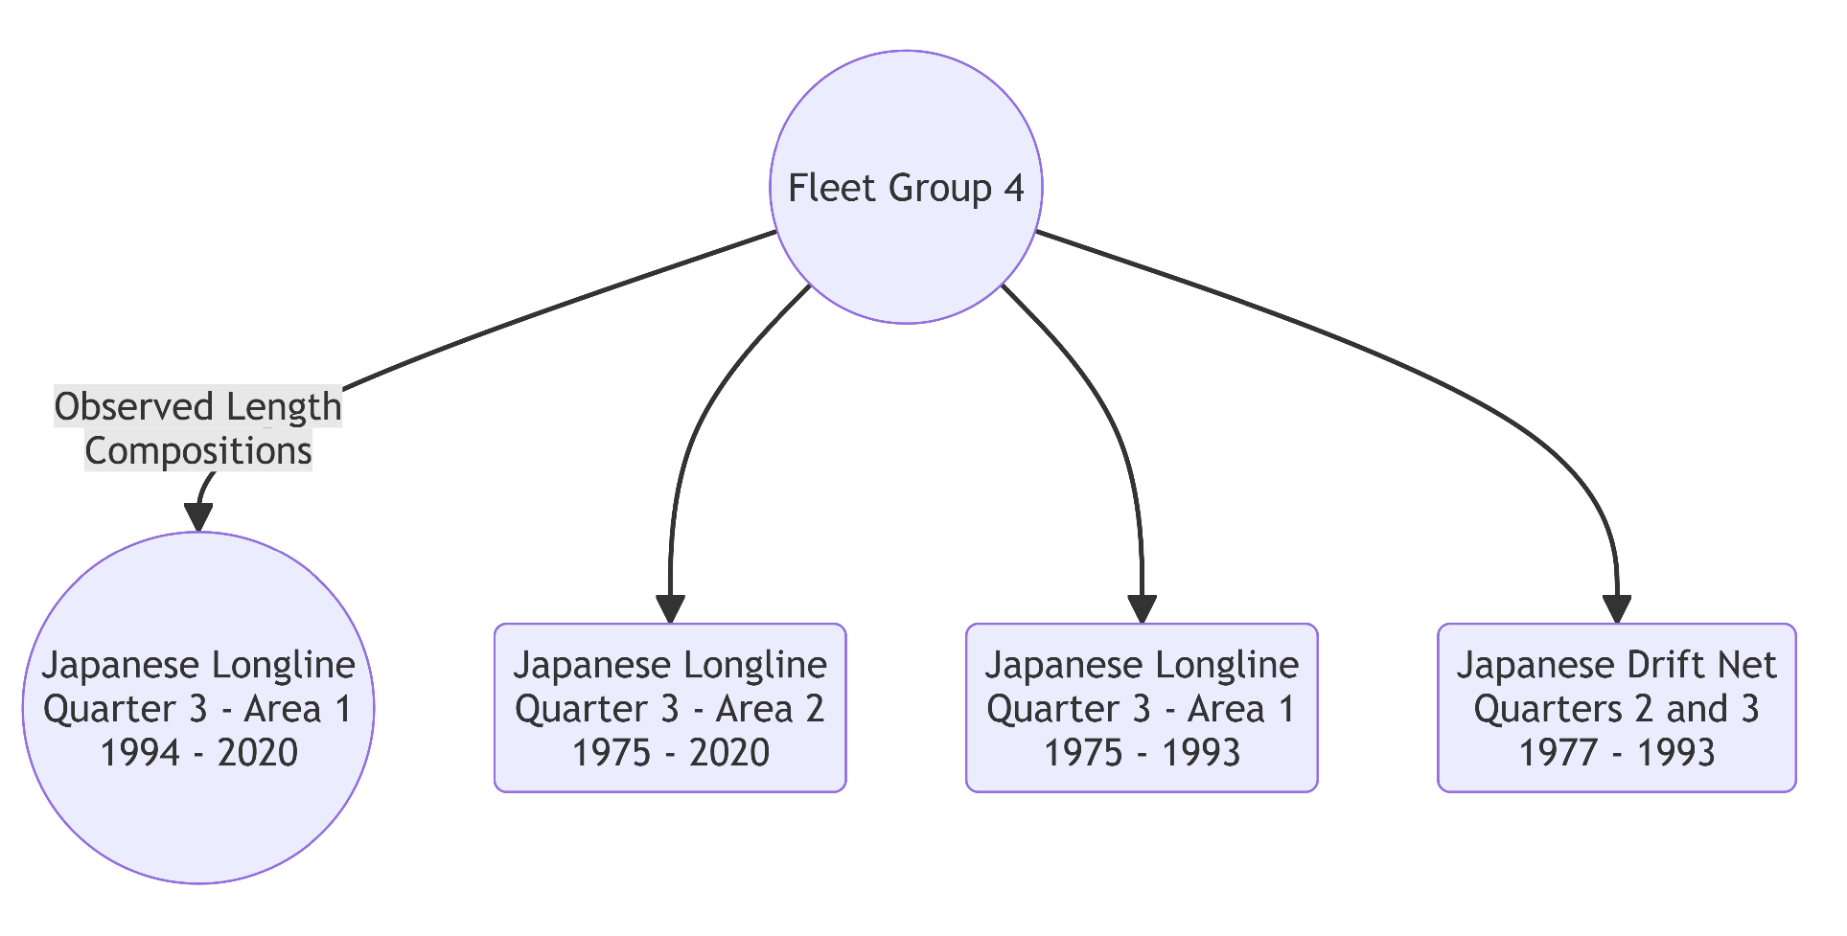

Figure 1.5. Fleet group 5

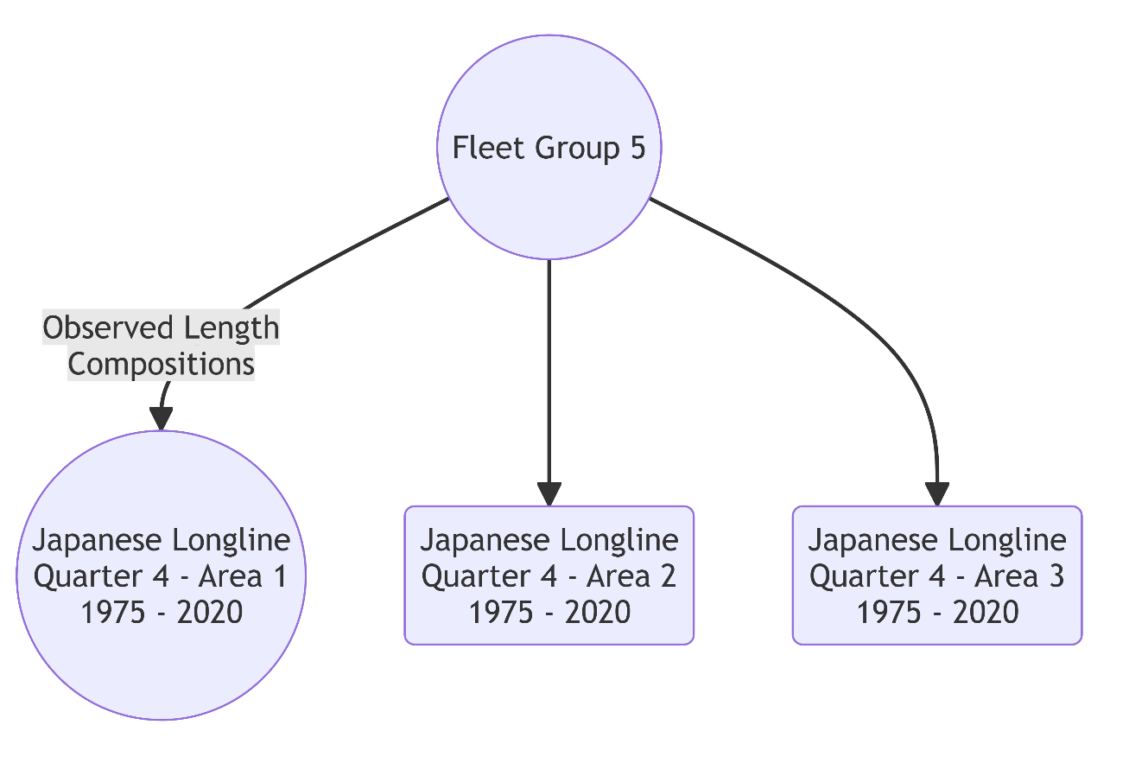

Figure 1.6. Fleet group 6

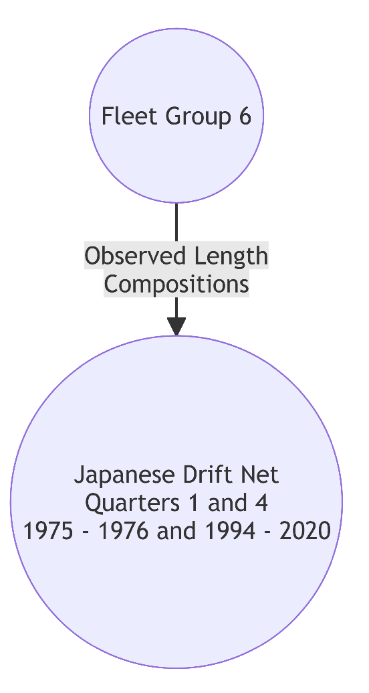

Figure 1.7. Fleet group 7

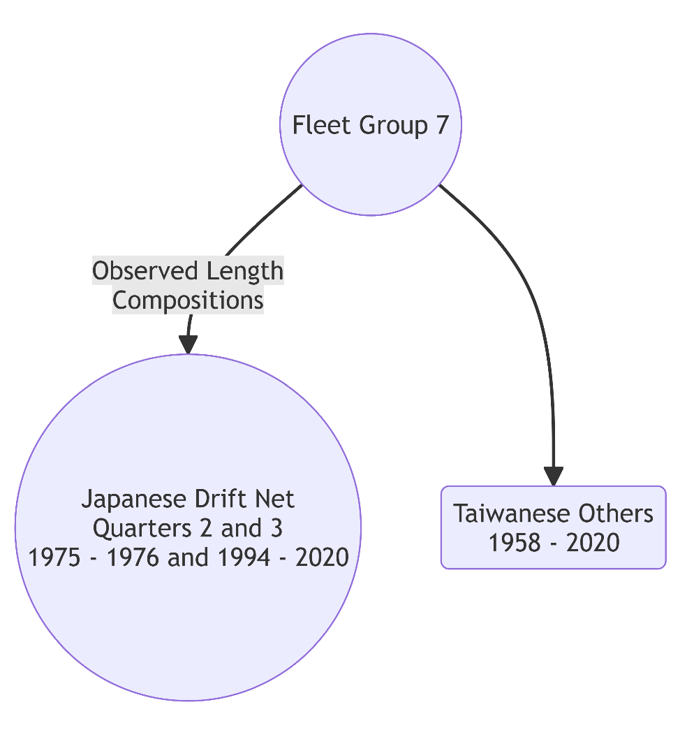

Figure 1.8. Fleet group 8

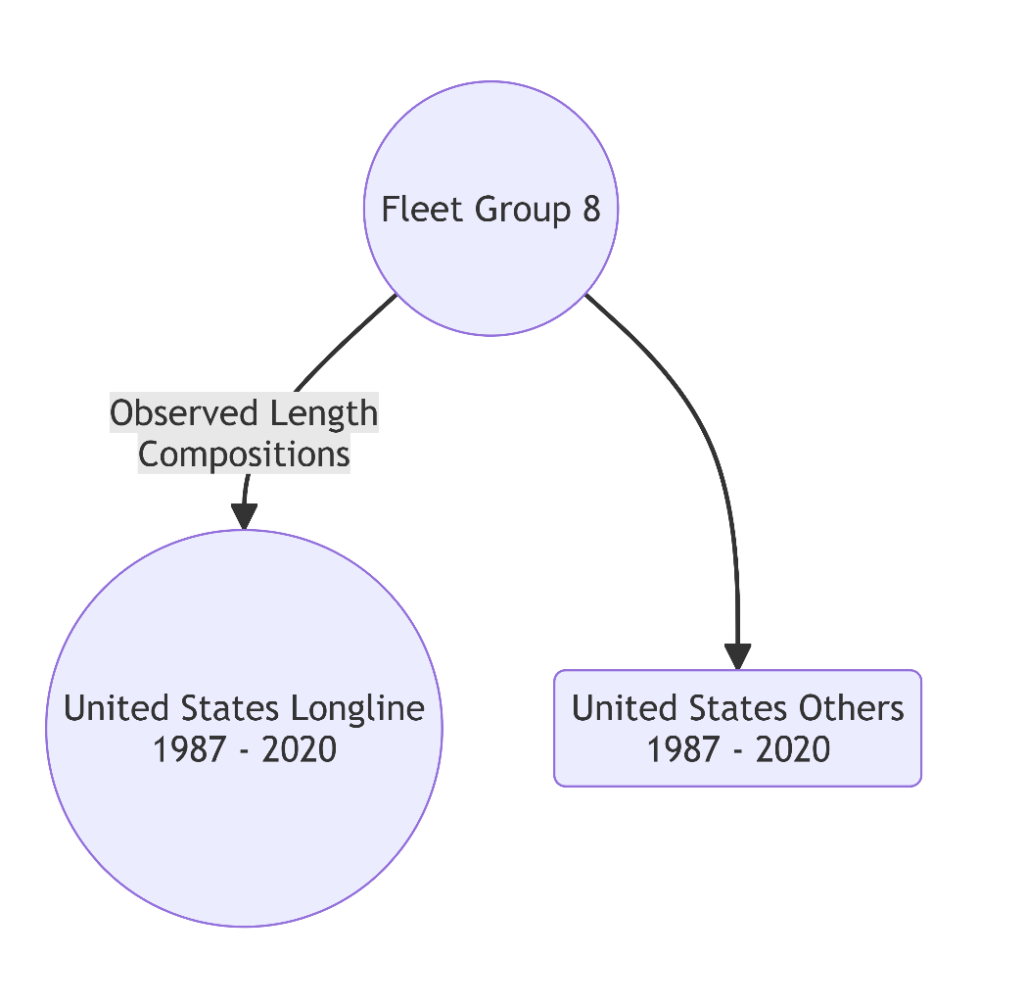

Figure 1.9. Fleet group 9

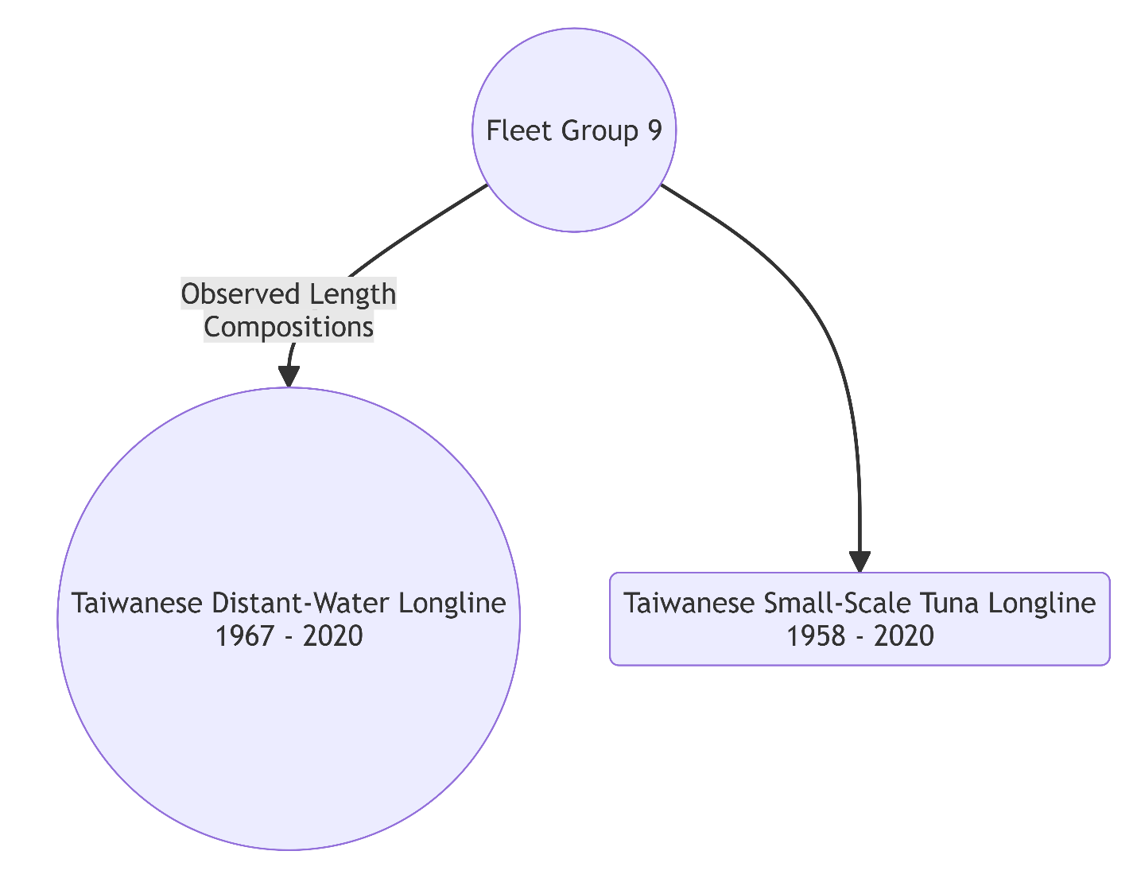

Figure 2.1.

Figure 2.2.

Figure 3. Japanese catch reported by ISC Billfish Working Group in 2025 by fleet group.

Figure 4. U.S. catch reported by ISC Billfish Working Group in 2025 by fleet group.

Figure 5.1. Japanese proportion in 2020.

Figure 5.2. Taiwanese proportion in 2020.

Figure 6.1.

Figure 6.2.
Figure.

Figure.

Figure.

Figure.

Figure.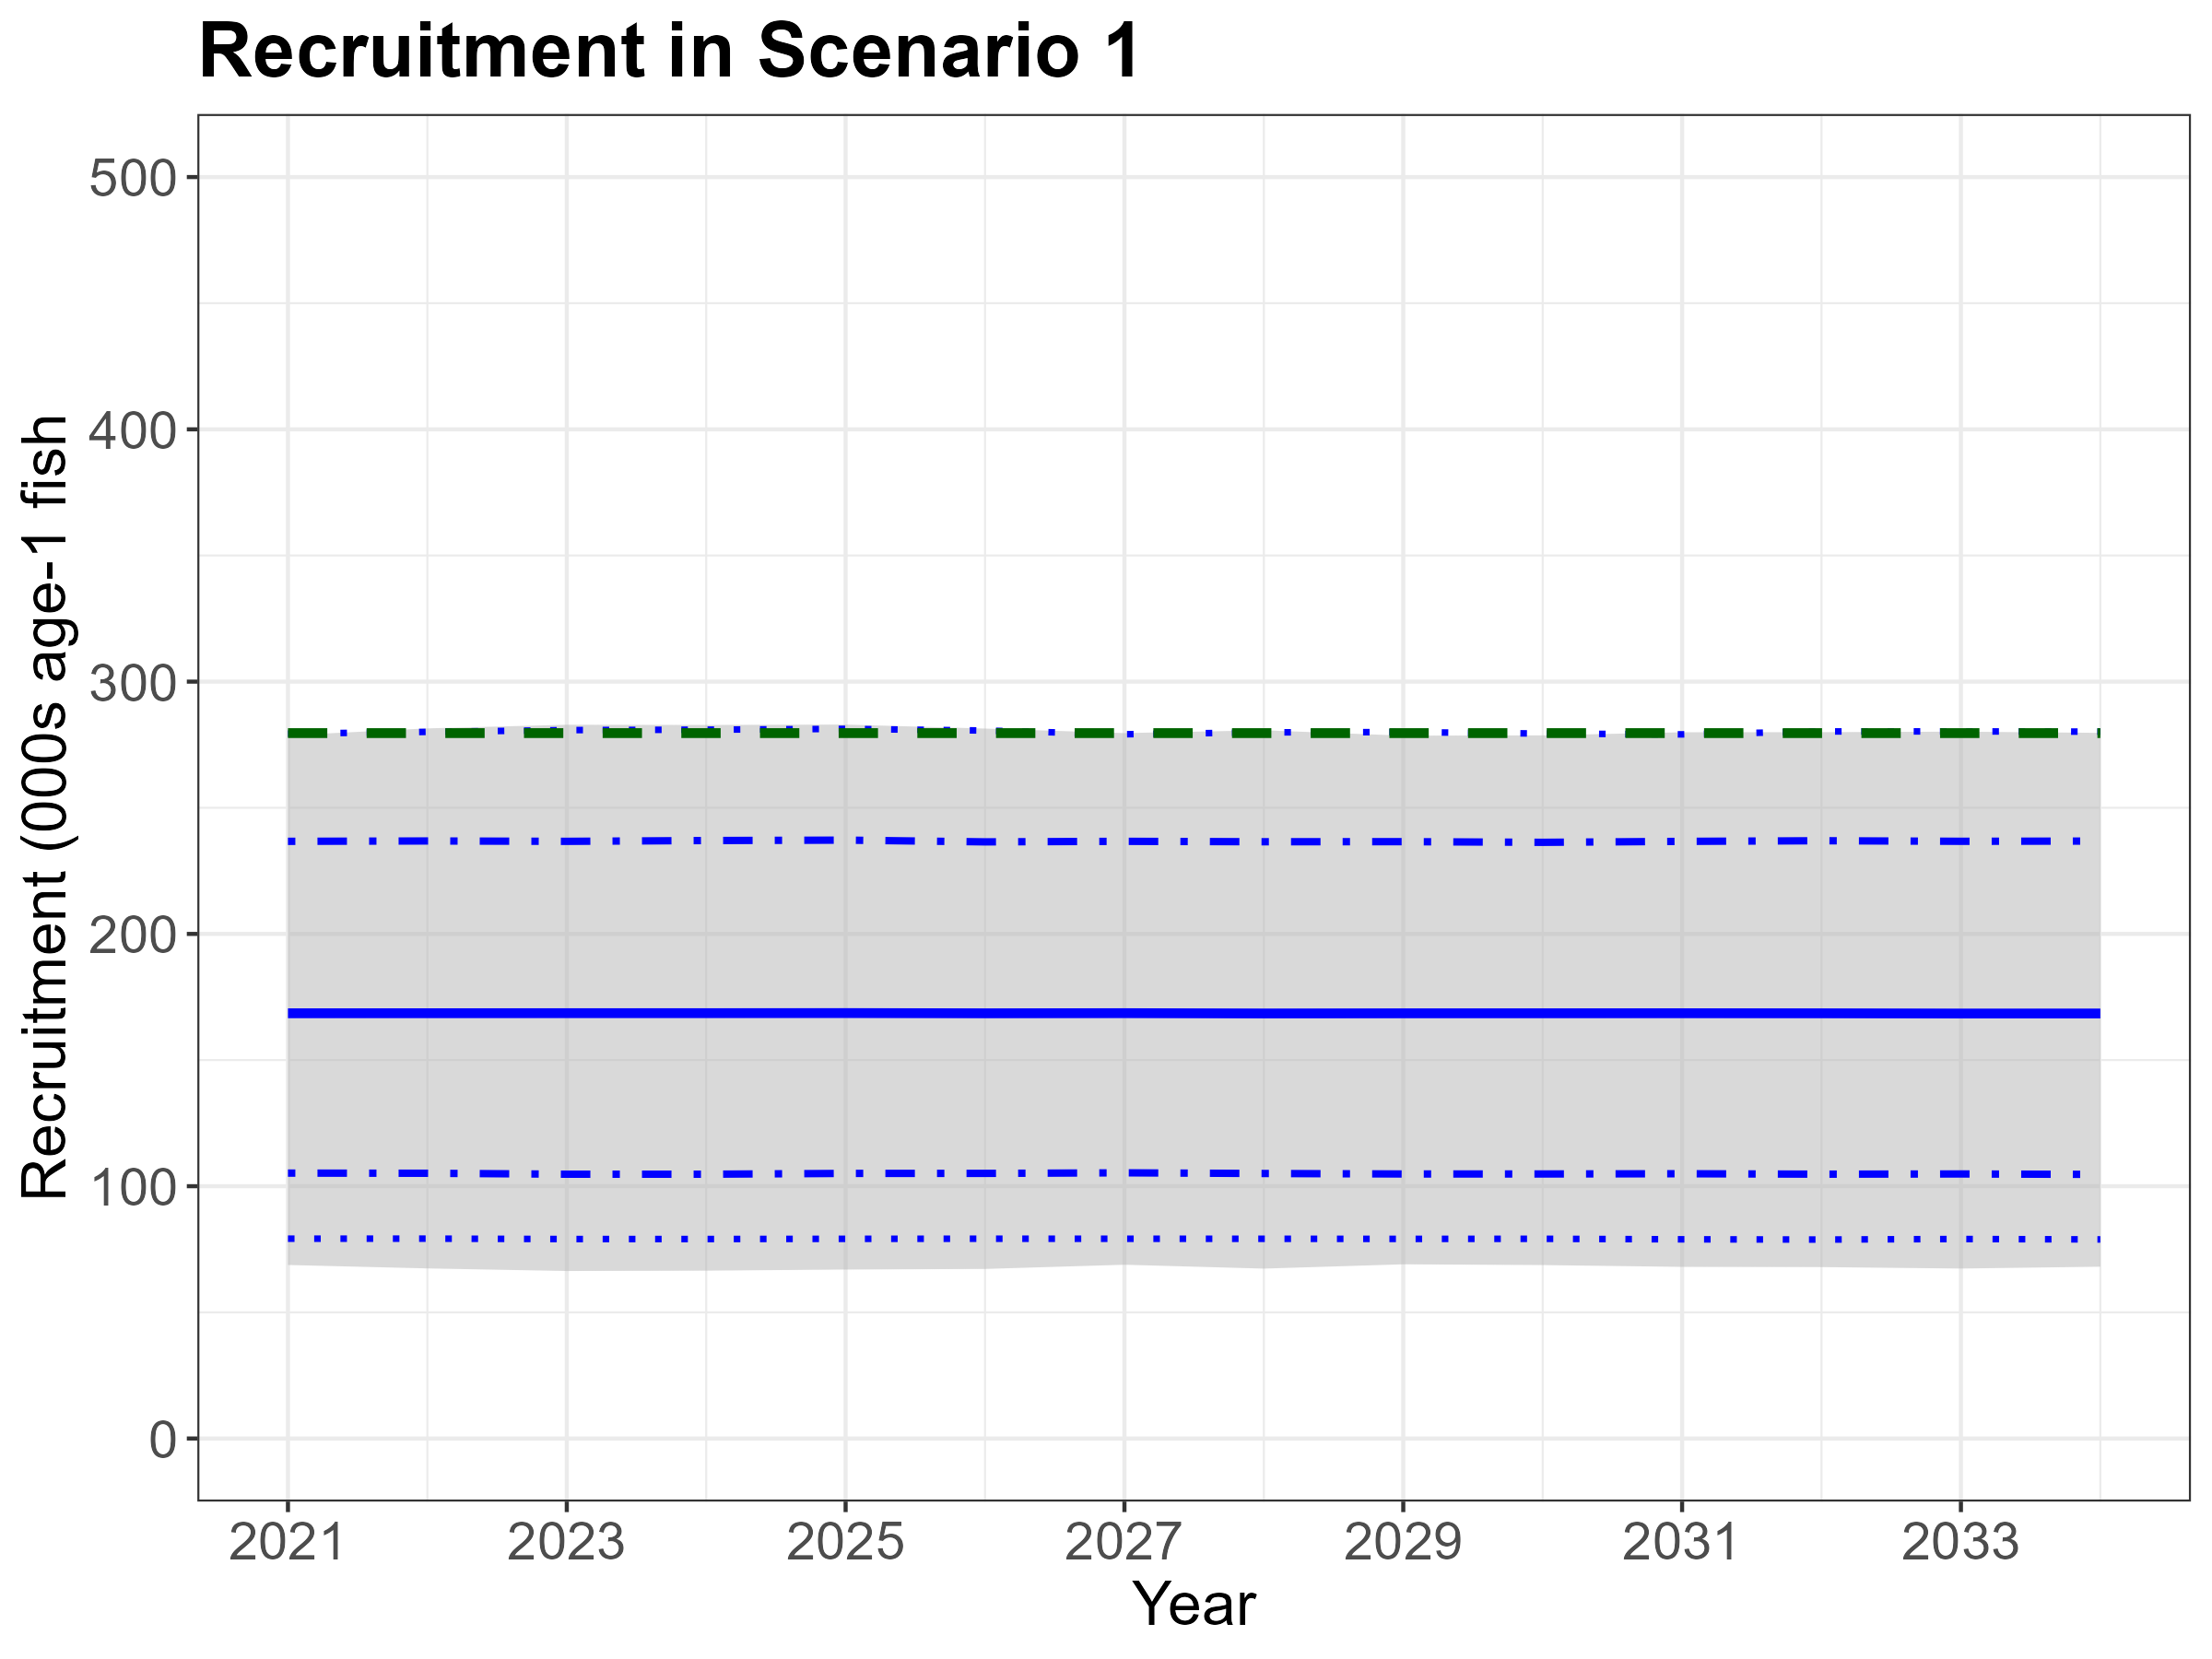
Figure.

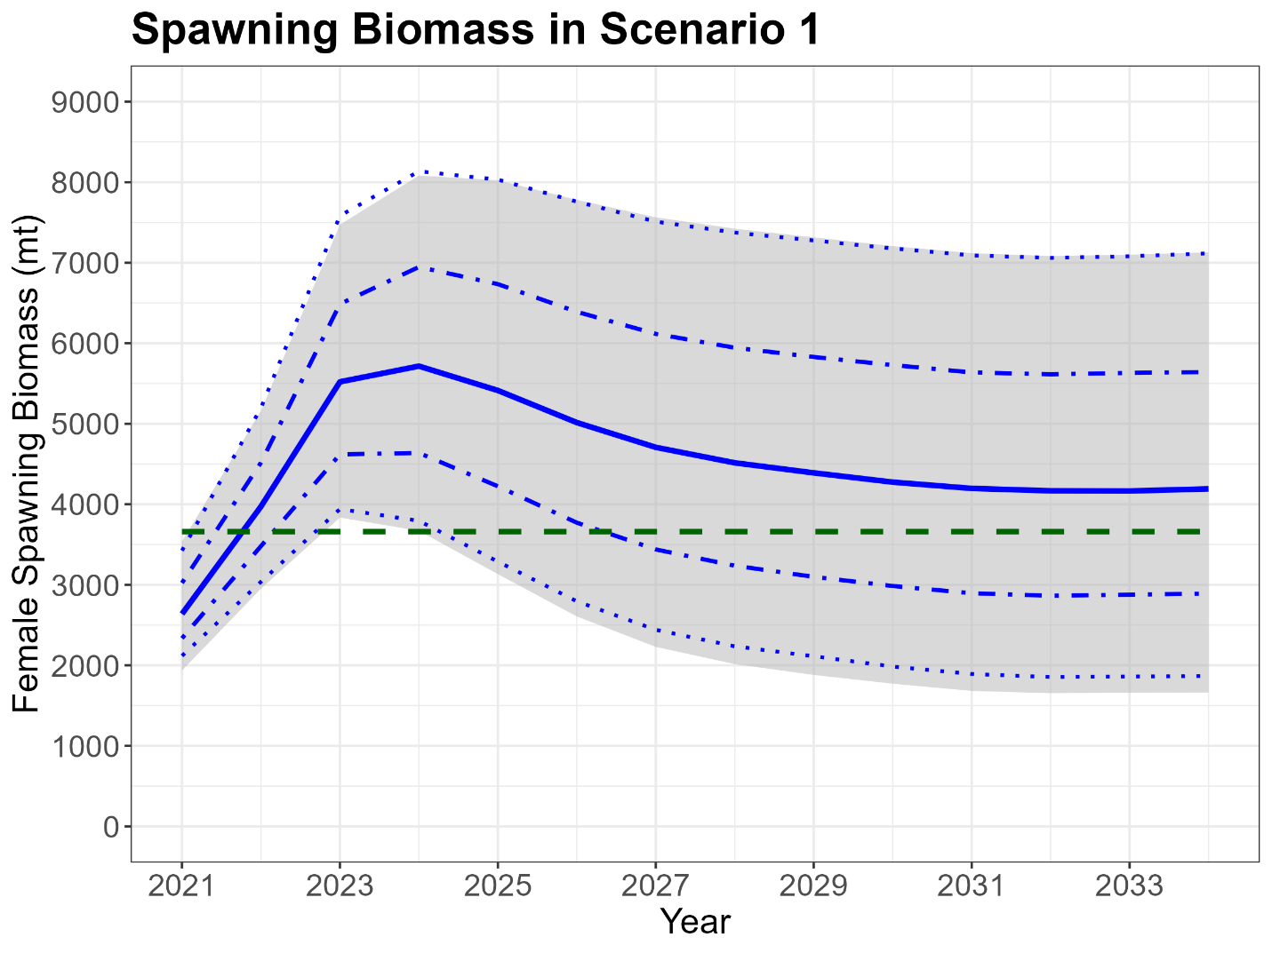

Figure.

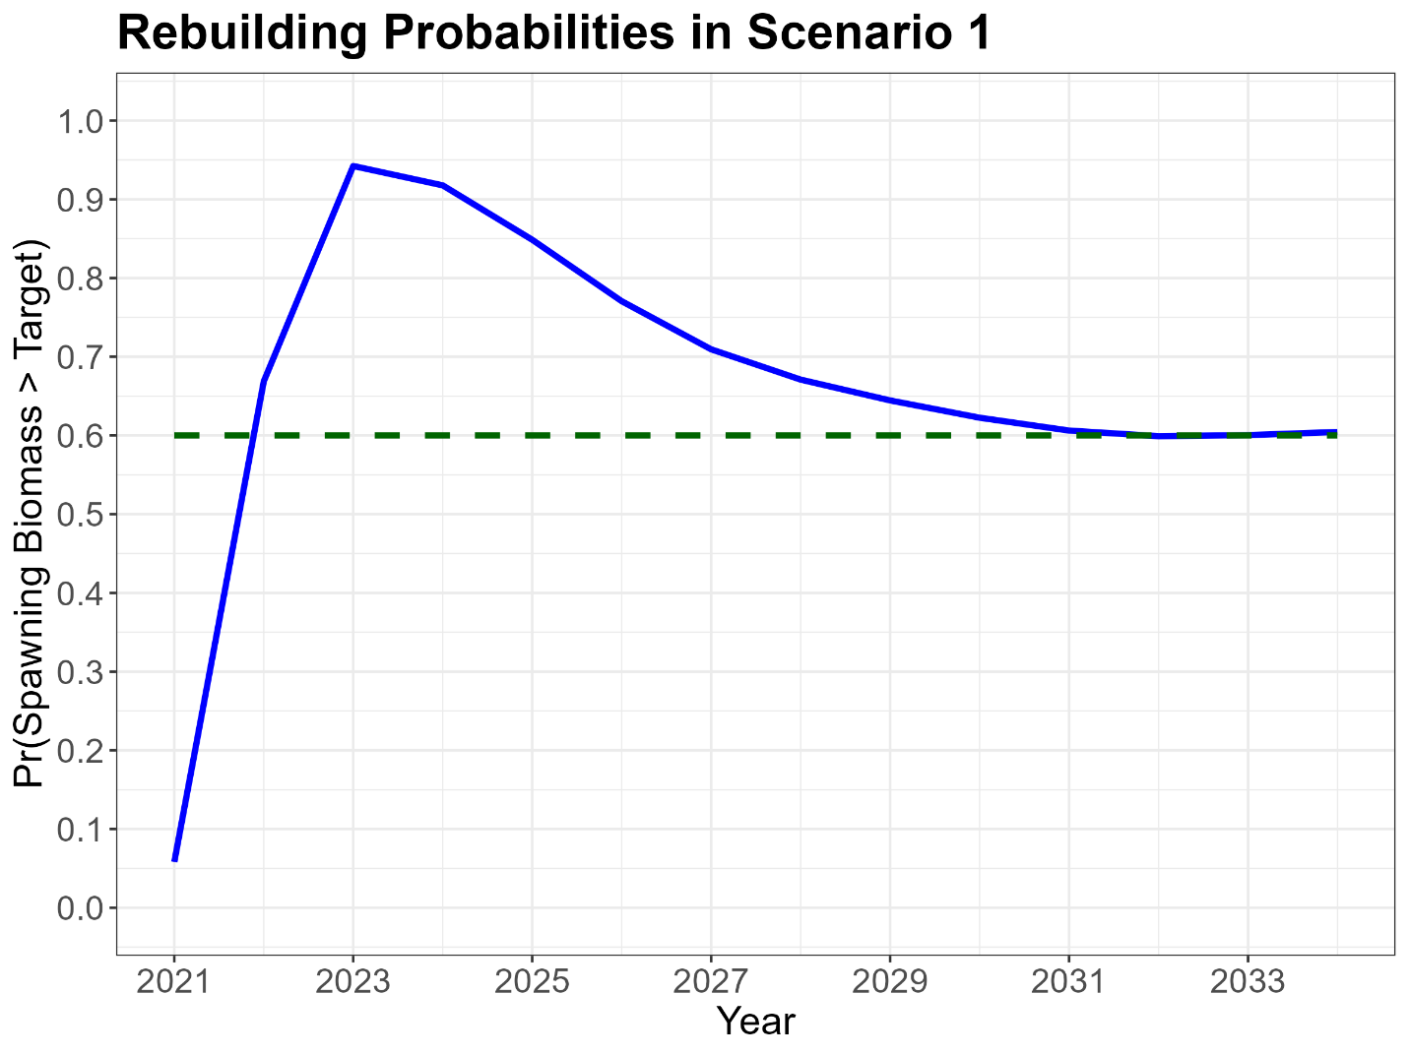

Figure.

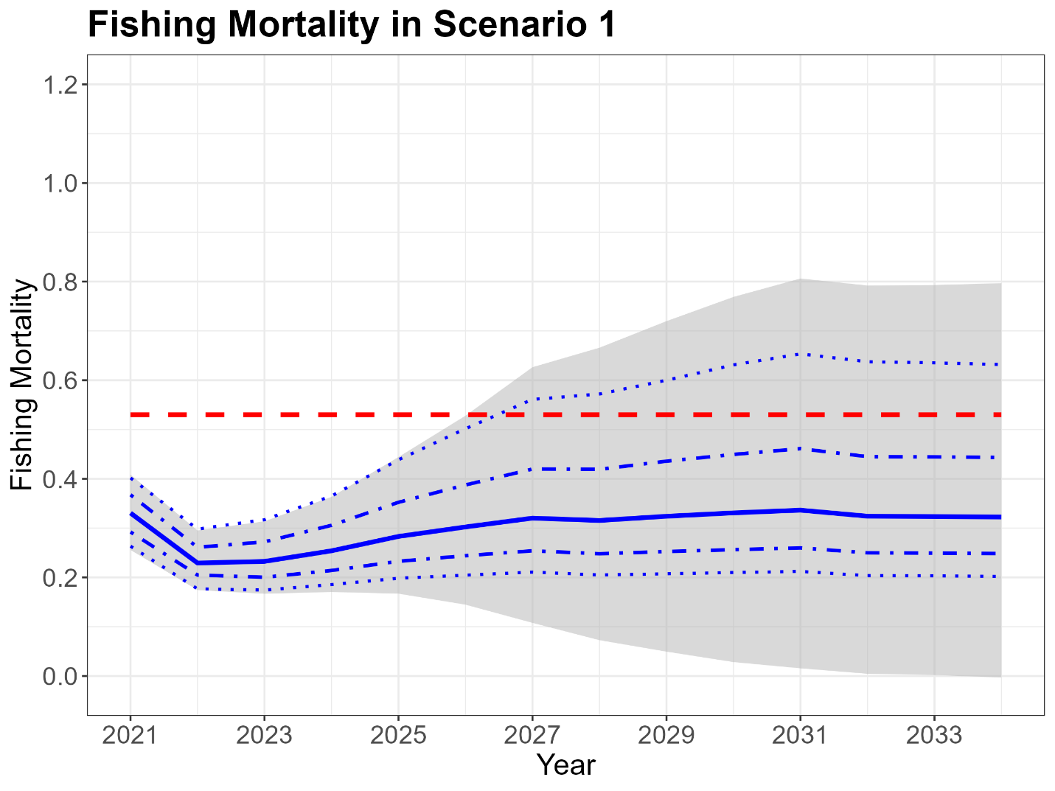

Figure.

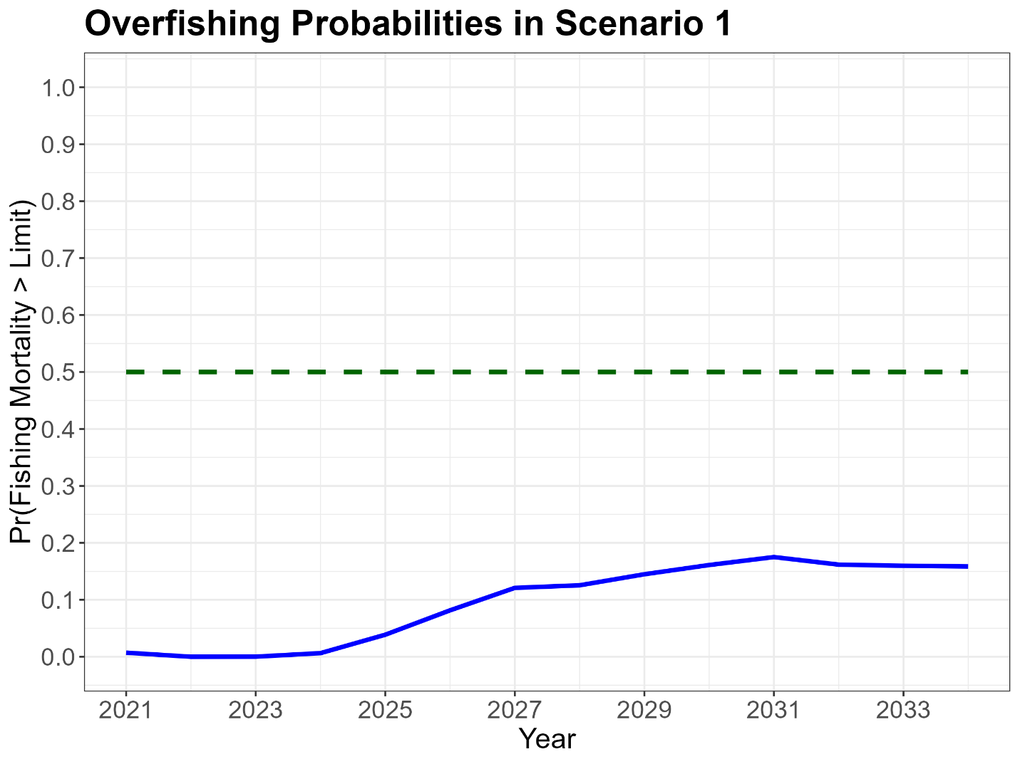

Figure.

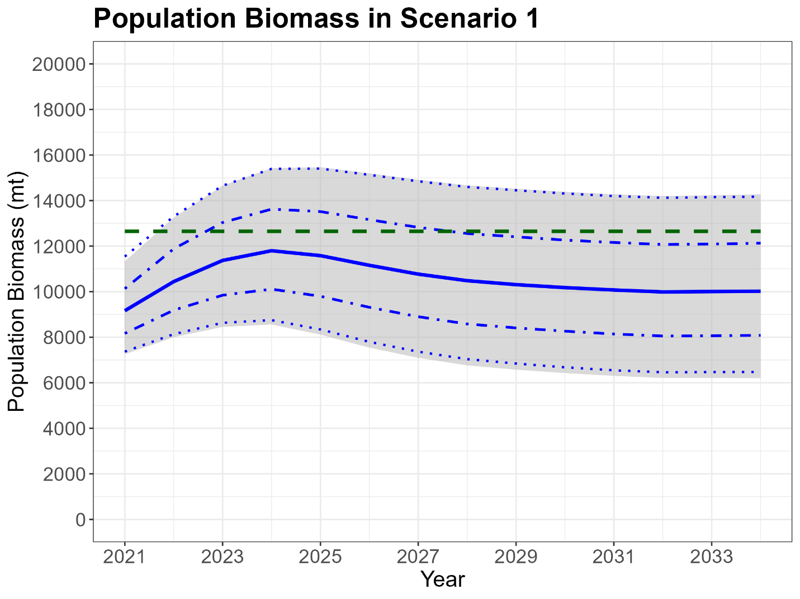

Figure.

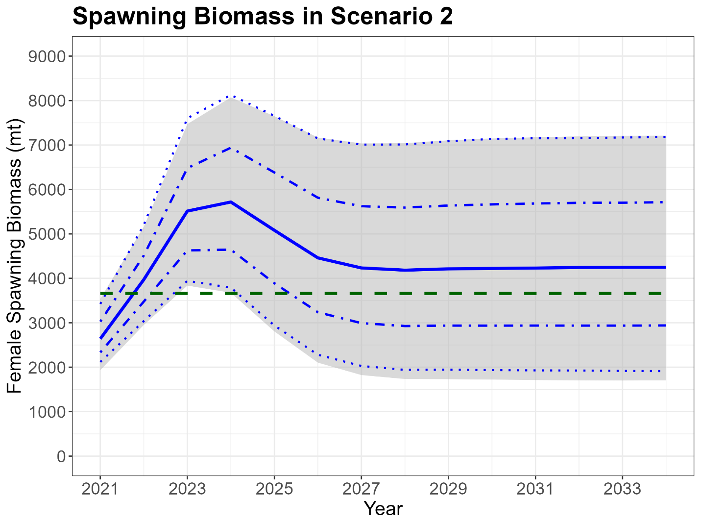

Figure.

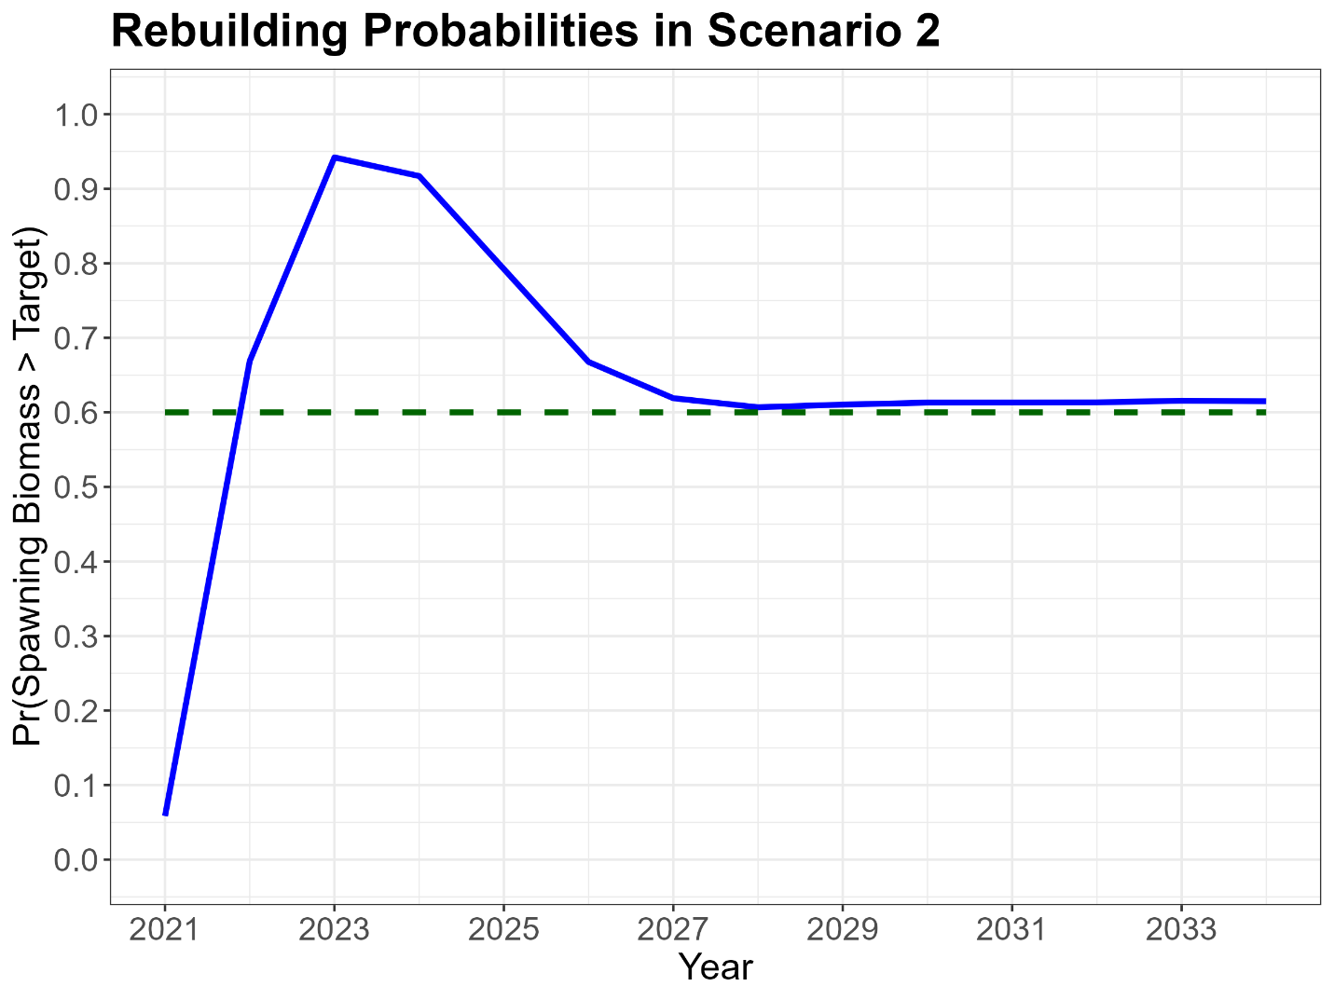

Figure.

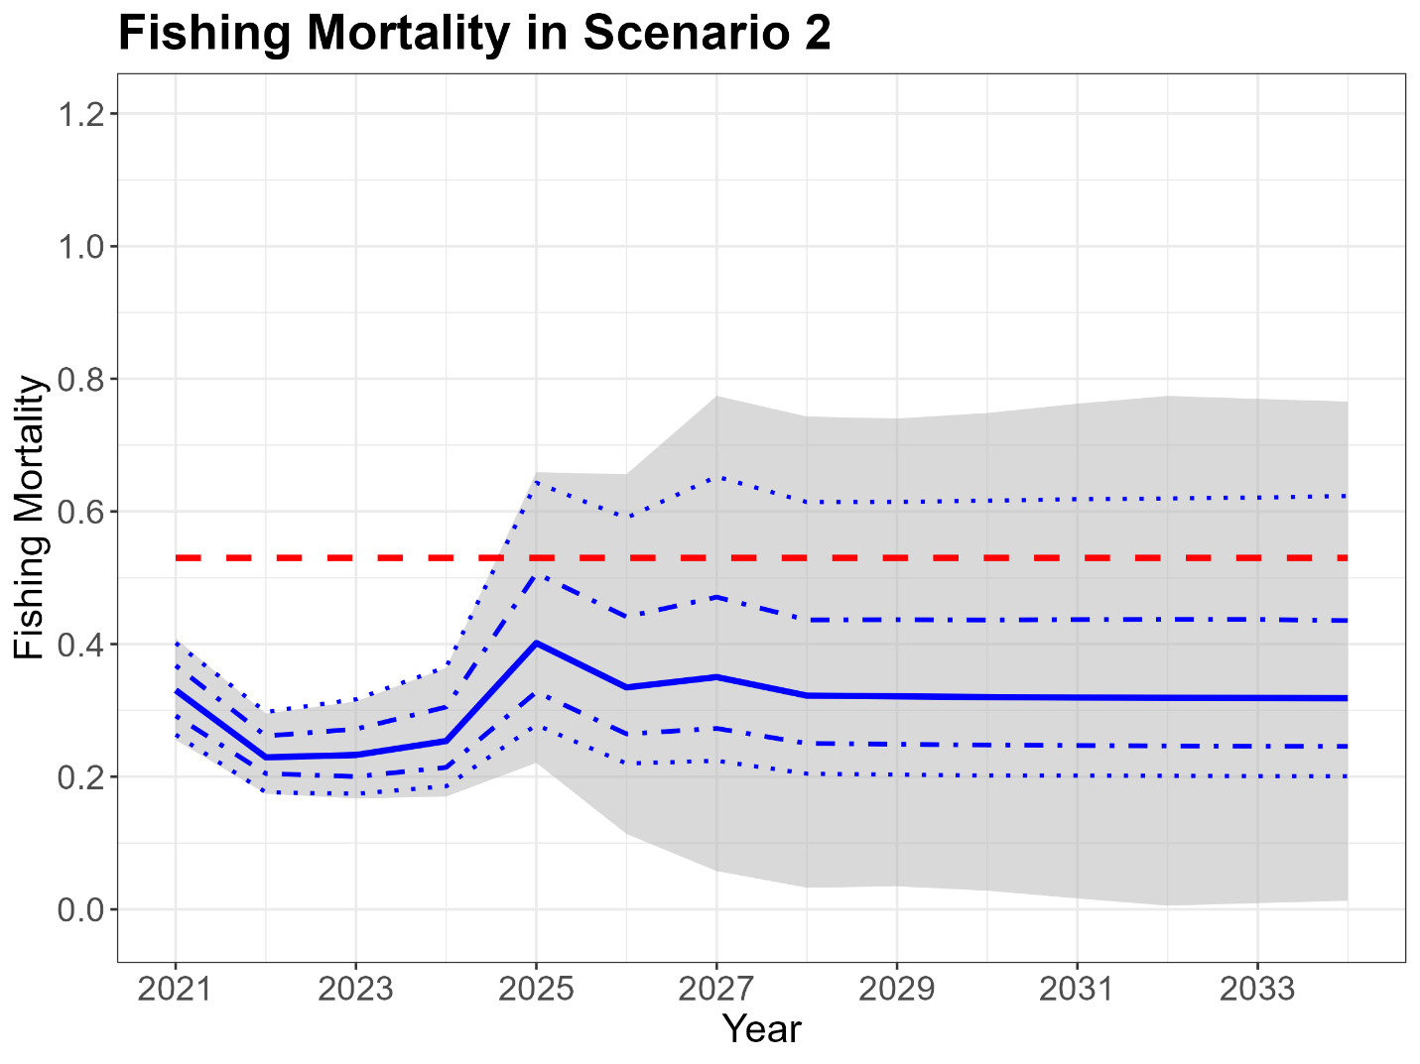

Figure.

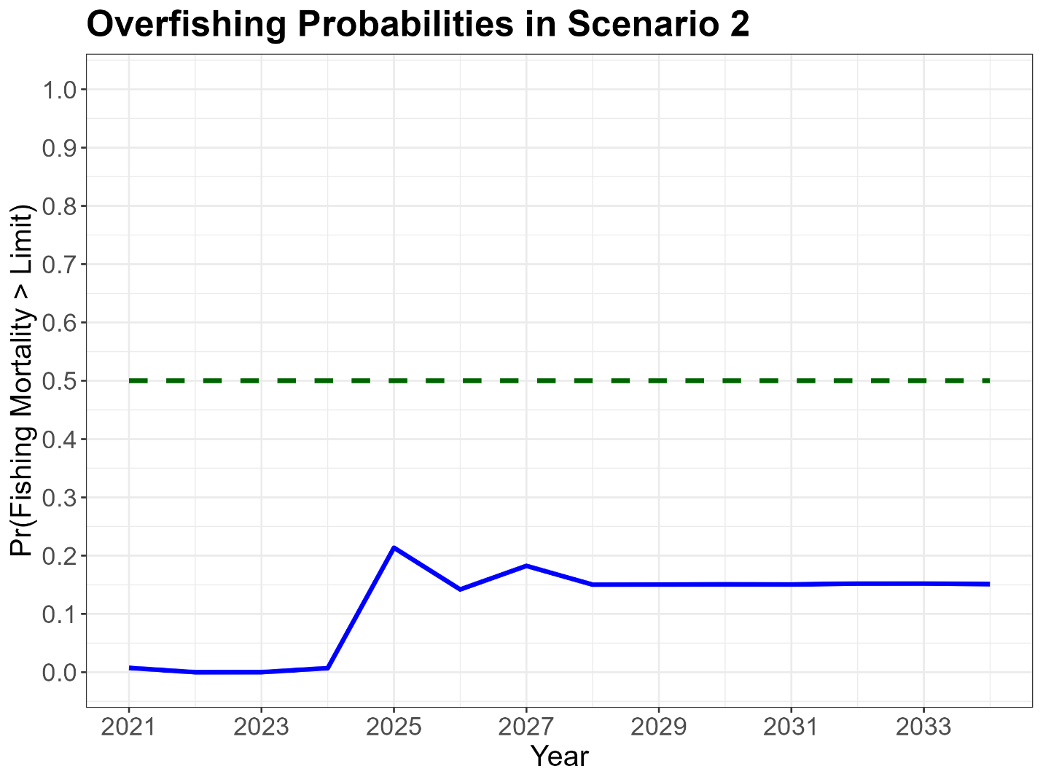

Figure.

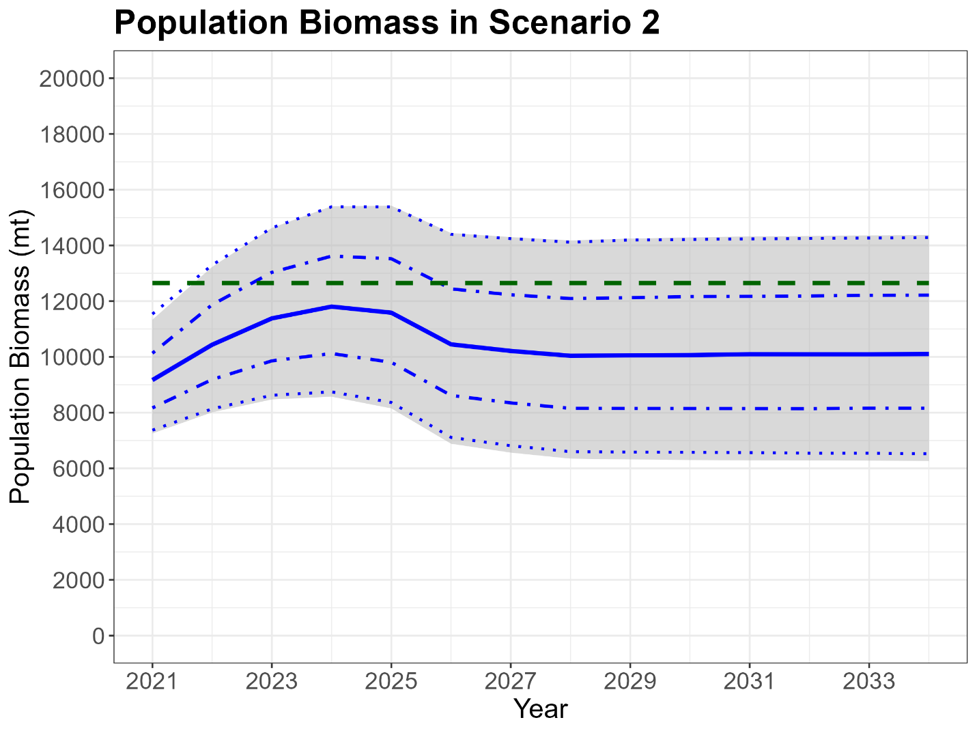

Figure.

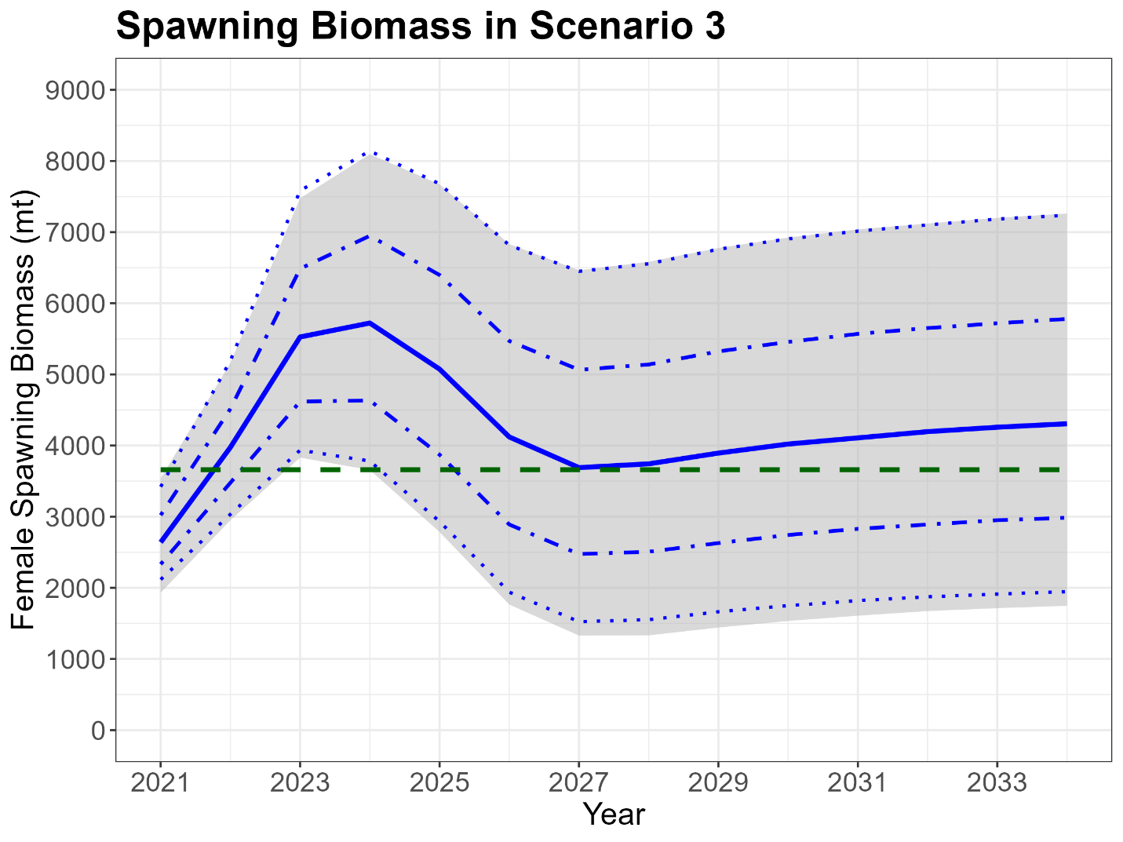

Figure.

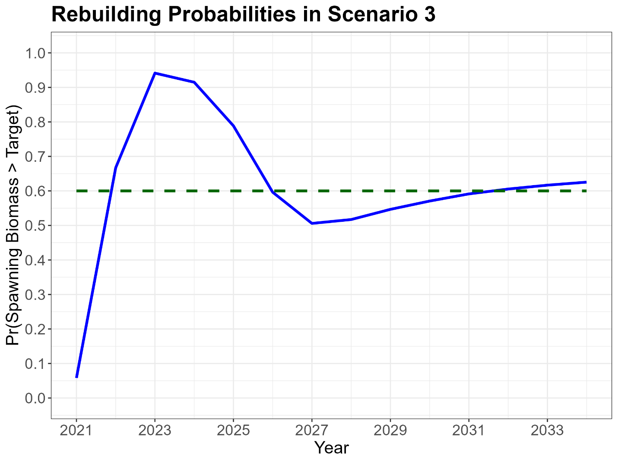

Figure.

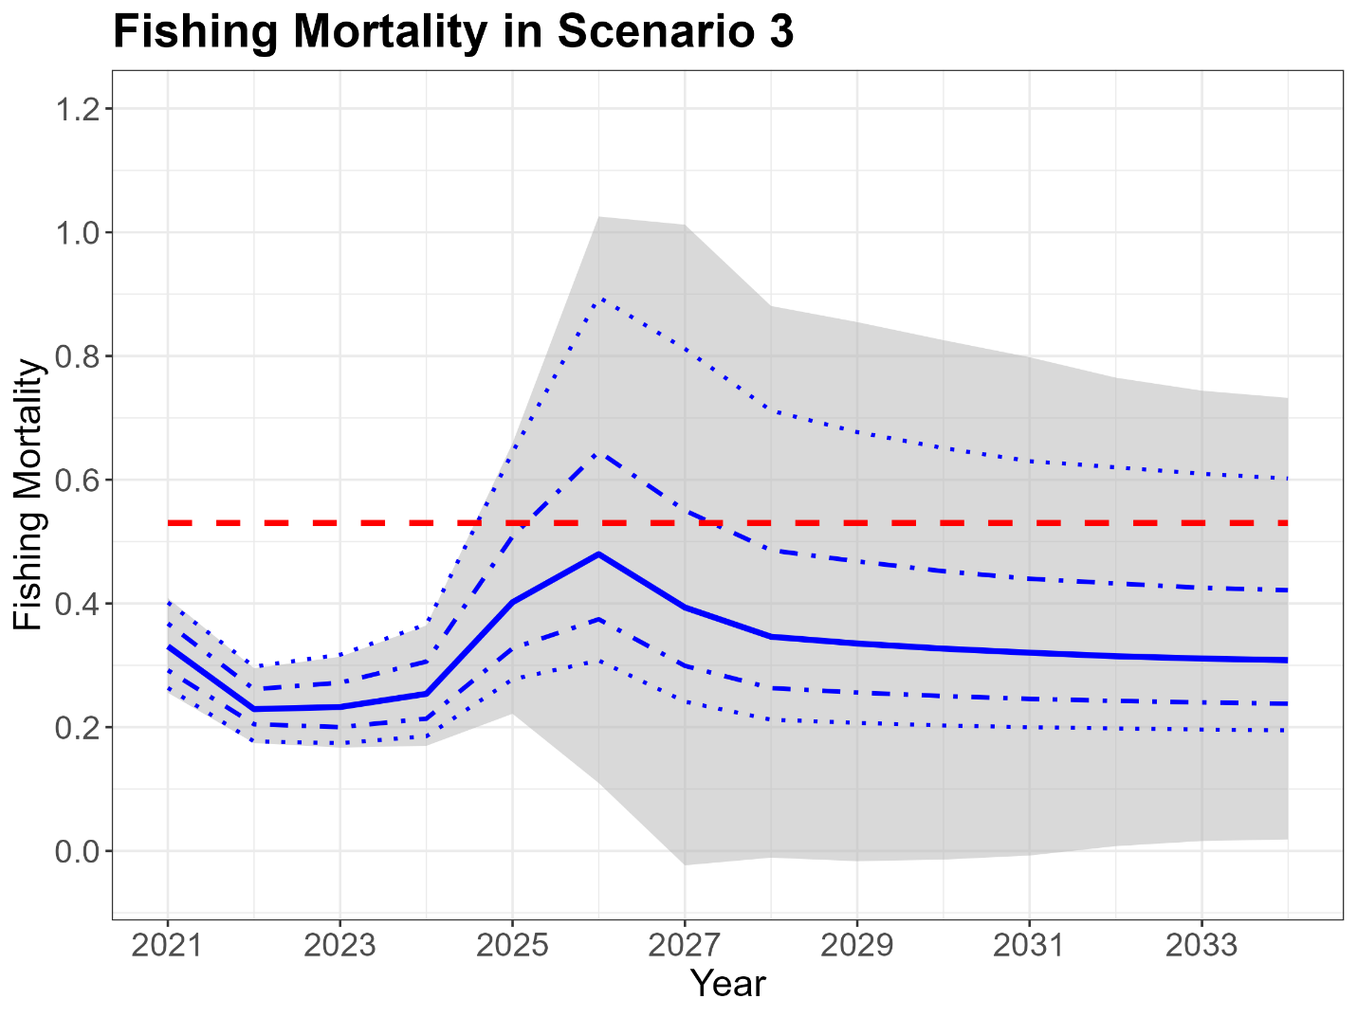

Figure.

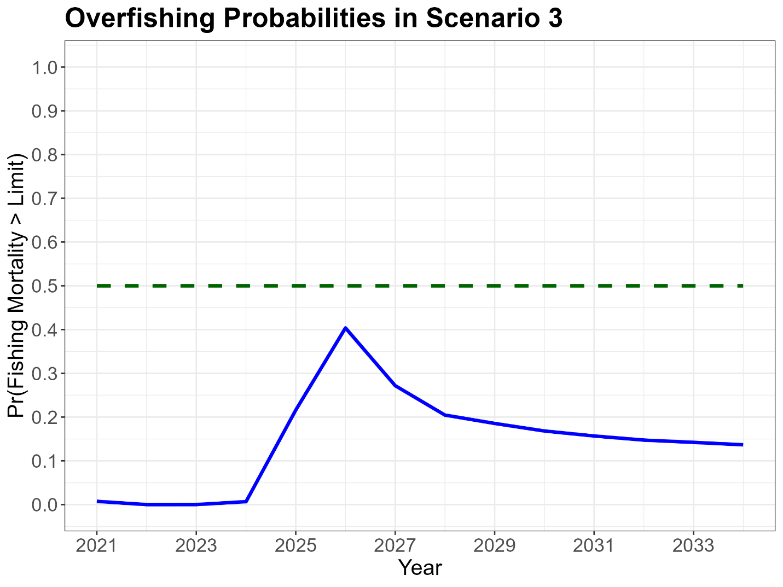

Figure.

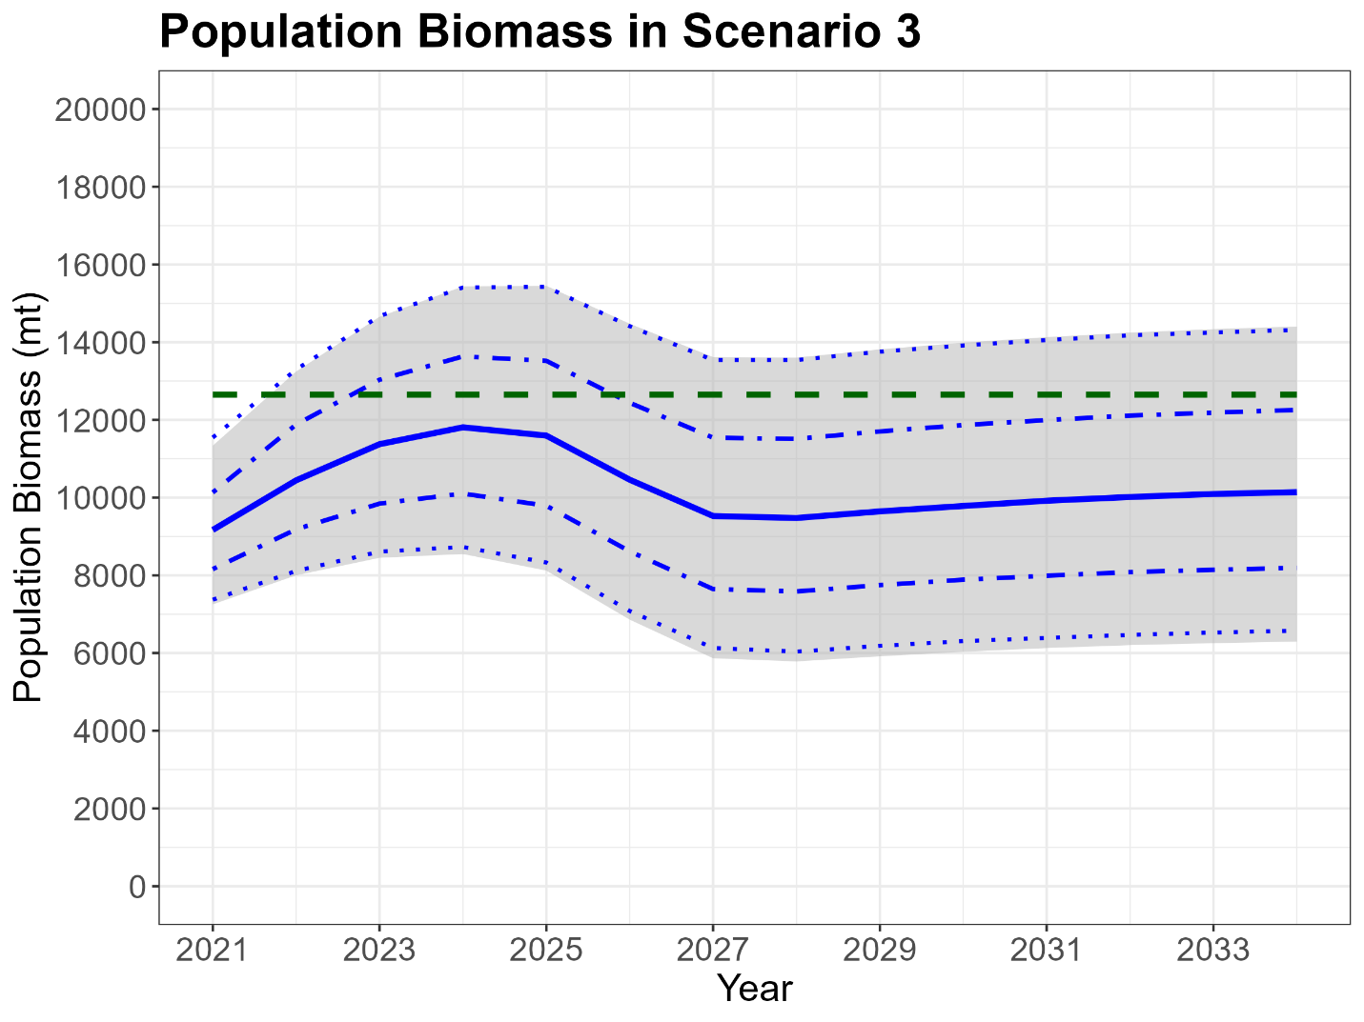

Figure.

